FINAL TEST
PART 1: (2ps)
Directions: In this part of the test, you will write ONE sentence that is based on a picture. With each picture, you will be given TWO words or phrases that you must use in your sentence. You can change the forms of the words and you can use the words in any order. Your sentences will be scored on
-Appropriate use of grammar and
-The relevance of the sentence to the picture

1.


Answer: She is doing yoga by the sea

2.
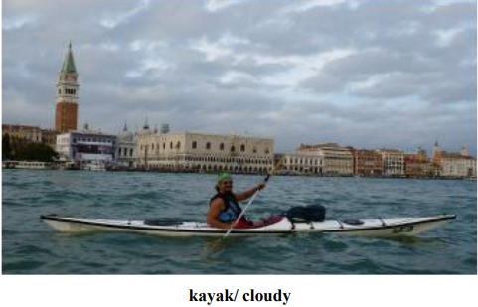

Answer: He likes kayaking when it is cloudy

3.
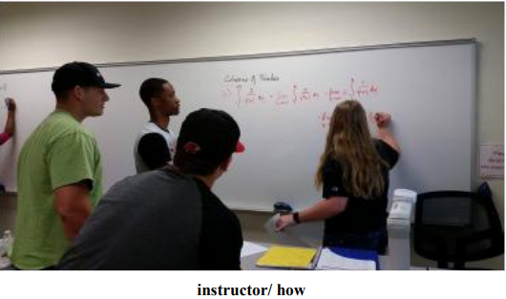

Answer: The instructor is explaining how to do homework

4.



Answer: This camera help her take beautiful pictures.

5.
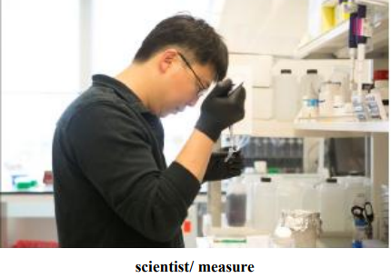

Answer: This scientist is measuring liquid which he is researching.

PERT 2: (3PS)
Directions: In this part of the test, you will show how well you can write a response to an email. Your response will be scored on
-The quality and variety of your sentences,
-Vocabulary, and
-Organization
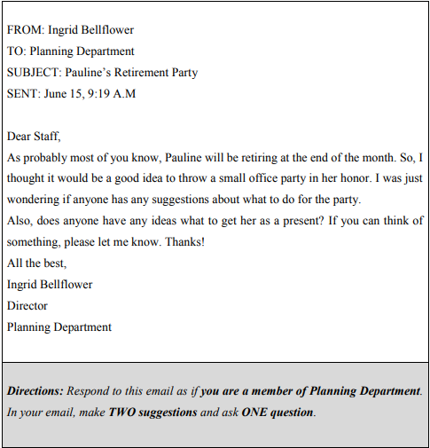
From, Tên của nhóm
To: Ingrid Bellfloewr
Subject: Pauline’s retirement party
Sent: June 16, 9:19 A.M
Dear Mr. Bellflower,
I am very happy to receive your email. With reference to Pauline’s Retirement I think we should plan a party for Pauline. The party take place after work. We could prepare something like candy, cookie then order pizza over the phone and some beer can be more delicious in this case. Participants shold be members of planning Department. It doesn’t need too many people because I think it should be a small party with the warin and friendly atmosphere, Why don’t we buy a beautiful big flower which is enclosed full of our best wishes? It will be a meaningful present for Pauline.
What do you think about my idea above? I trust this email resolves Queries. Please feel free to contact me if I can be further assistance.
Sincerely,
Tên của nhóm

PART 3: (5ps)
Directions: in this part of the test, you will write an essay in response to a question that ask you to state, explain, and support your opinion on an issue. Typically an effective essay will contain 300 – 350 words. Your response will be scored on:
-Whether your opinion is supported with response and/ or examples,
-Grammar,
-Vocabulary, and
-Organization
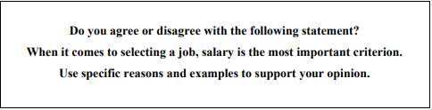
It is true that some job seekers select their careen based on salary level. While I accept that this may suit many people, I believe that others base their job choice on more impotant considerations rather than earnings alone. On the one hand, there are a variety of reasons why people should apply a high-paying job. One reason is that a wage plays an integral part in guaranteeing an acceptable standard of living. Being offered a high salary allows employees to meet their basic needs, buy a comfortable house and perhaps even go on luxury holidays. Furthermore, one of the best motivations is a competitive salary. For example, the head offer a pay rise to a new employee who is able to achieve a sales target during the year. This rewarding perk will encourage the new sales staff to try hard and enhance the level of job performance.
On the other hand, most people have different reasons apart from salary to choose their accupations firstly, job satisfaction is a crucial factor. If a person adores the outdoor life, he will not be happy being a stockbroker or a financier, no matter that the salaries for both jobs are extremely high. Secondly, contributing to the community is another reason to consider a job. This could bring a bout a much more civilized society. For instance, Mr. Kurt a Danishman, who has lived in VietNam for a bout 20 years, has constructed 6 schools and other facilities for disabled children instead of working for the Danish Embassy. In conclusion, it is certainly true that money can be an important factor for many people when choosing prospective employment, but this is by no means the consideration for everybody in marking a career decision.

